Shree Tulja Bhavani Temple Trust’s
Shri Tulja Bhavani College of Engineering, Tuljapur
Department of Civil Engineering & TPO
Faculty Profile
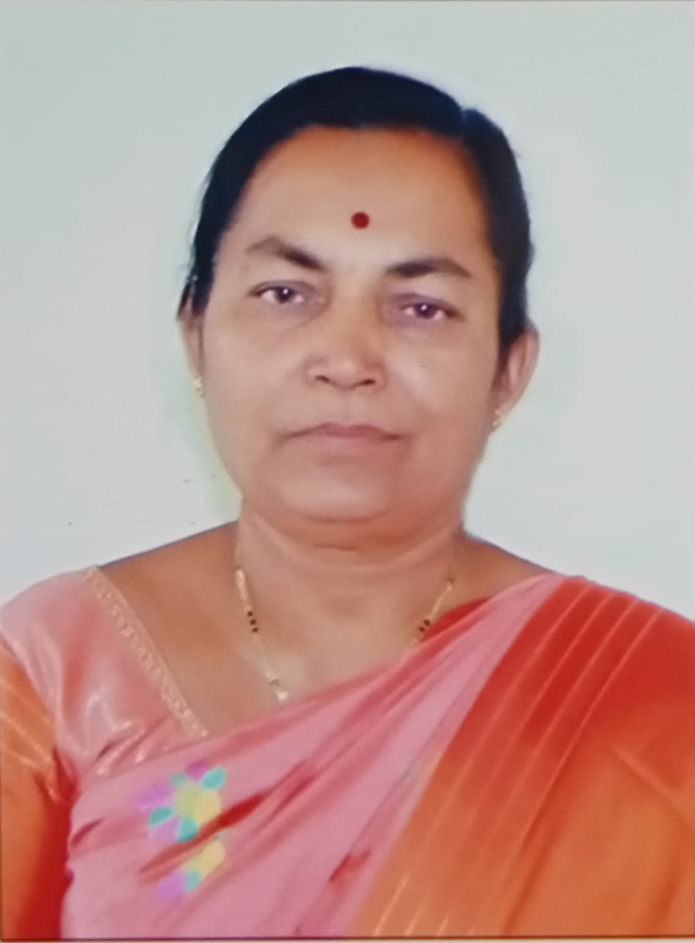
Name :Mrs. Chhaya Arjun Ghadge
Designation :Training and Placement Officer
E-mail Id :ghadge.c@gmail.com
Contact No. : 9890976305
Educational Qualification 1. M.E (ETC)
2.B.E. (ETC)
Professional Experience - TEACHING -- 34Yrs.

Responsibility Handled: 1. TPO
2. Worked in Admission Procedure
Paper/conference Attended: 10

FDP / Workshop /:- 15

Association with Professional Bodies : ISTE Member

Ghadge Chhaya Arjun
Name and Designation
Training & Placement Officer

