F.Y. B.Tech Student Strength

- Branch Intake
- Civil 60
- Mech 60
- ETC 60
- CSE 60

Total - 240

Induction Program-2018-19

- Period - 1st Aug. to 21 Aug.2018 (21 Days)
- Activities- Lectures on Human Values
- Creative Arts
- Sport Activity
- Yoga
- Guest Lecture
- Visits

Students Well come

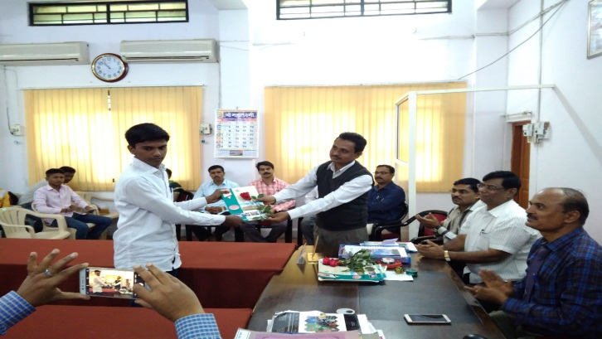
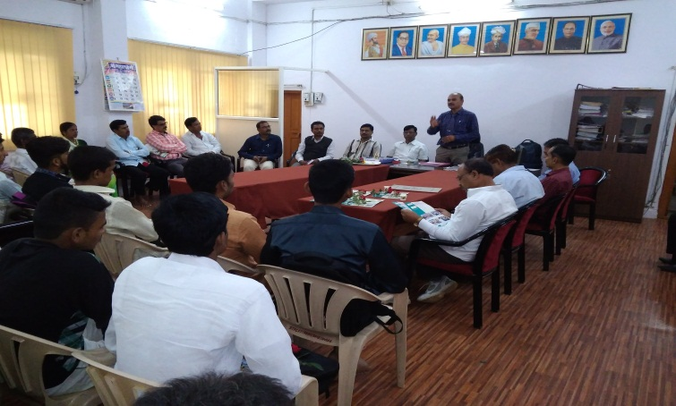

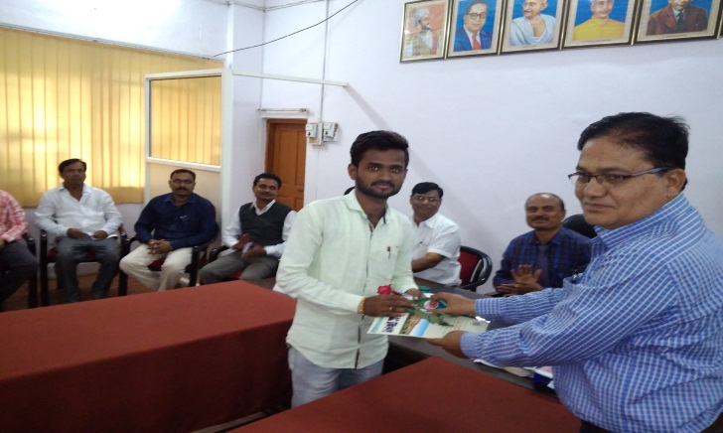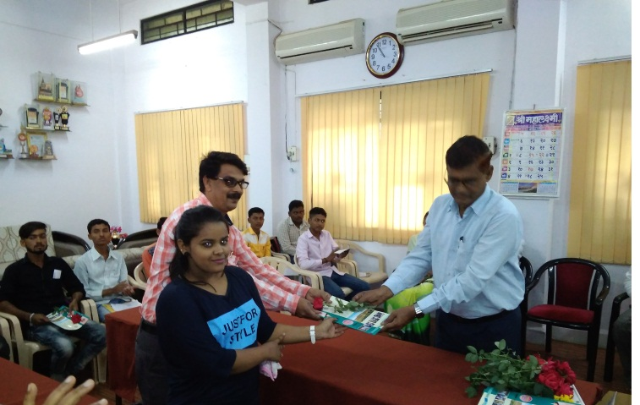
Orientation Program

o

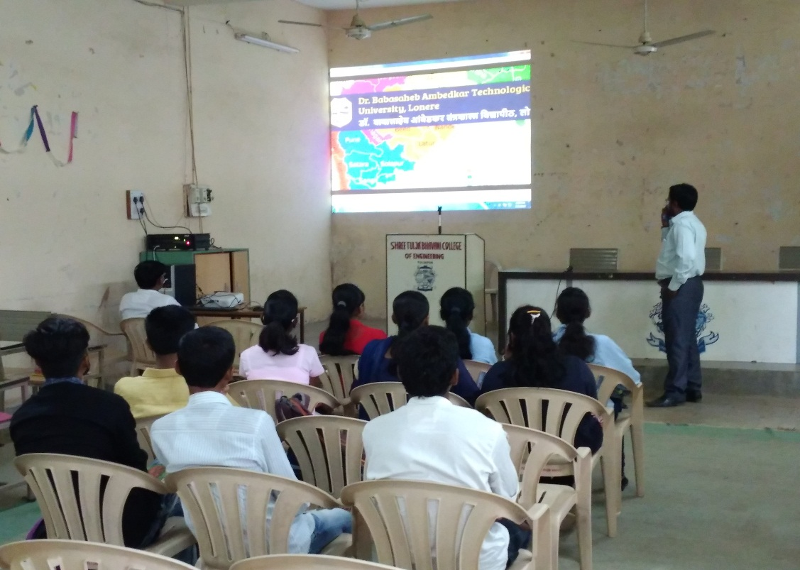

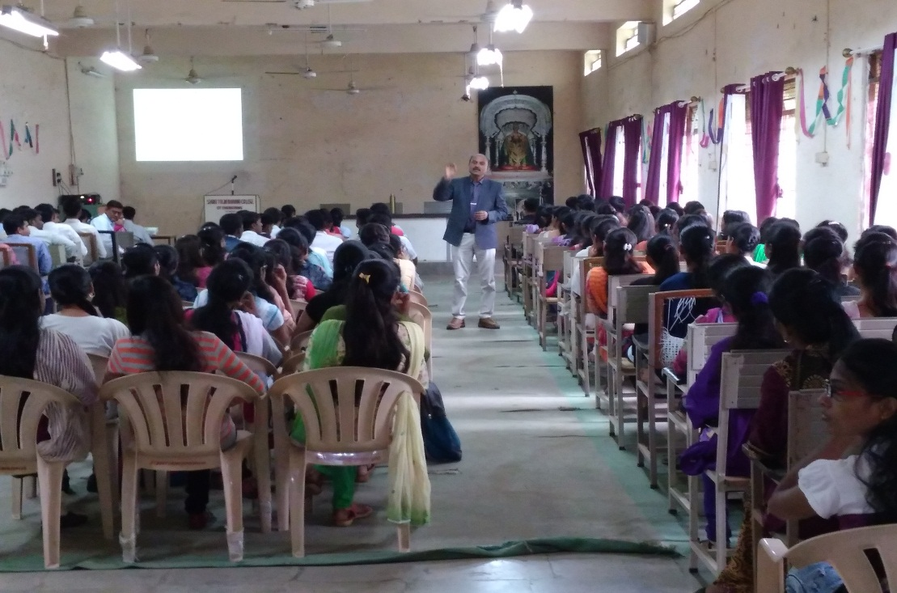
New Student Interaction with Principal sir

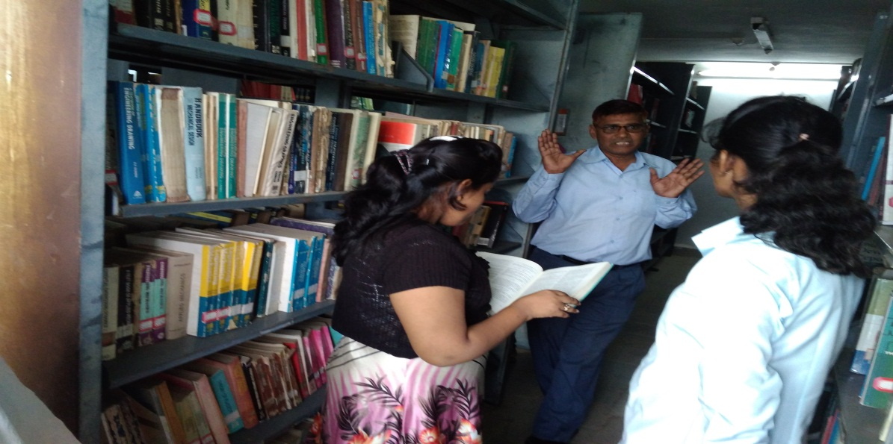

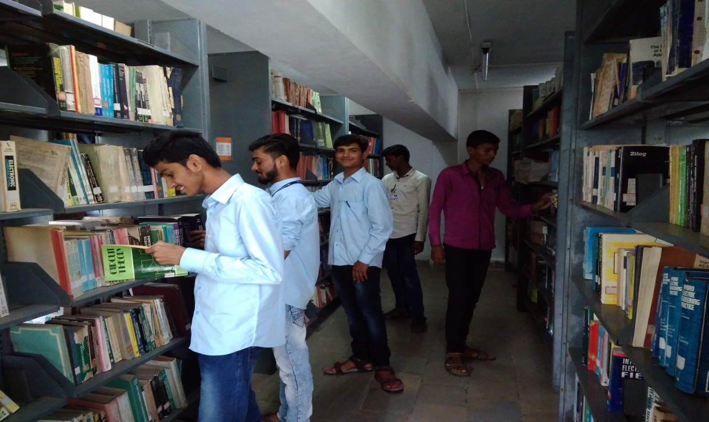

Library Visit

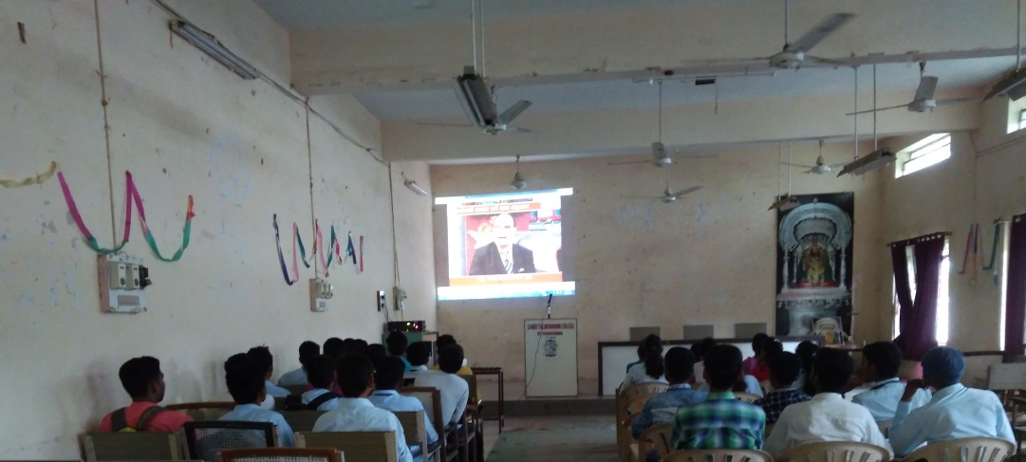

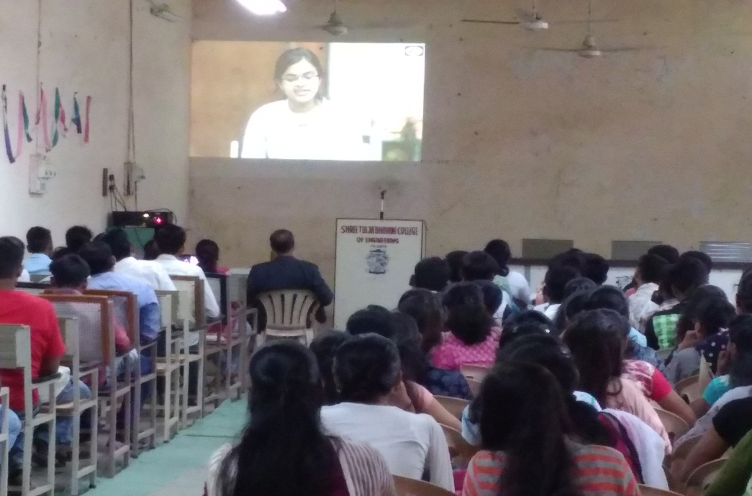

Motivational videos

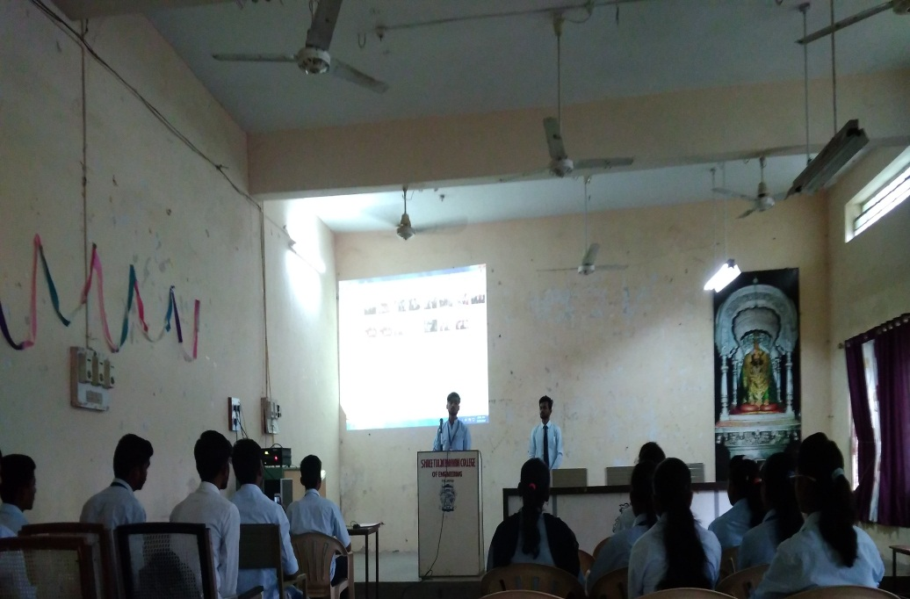

Students Presentation – Under Induction Program

Guest Lecture- Creative Arts

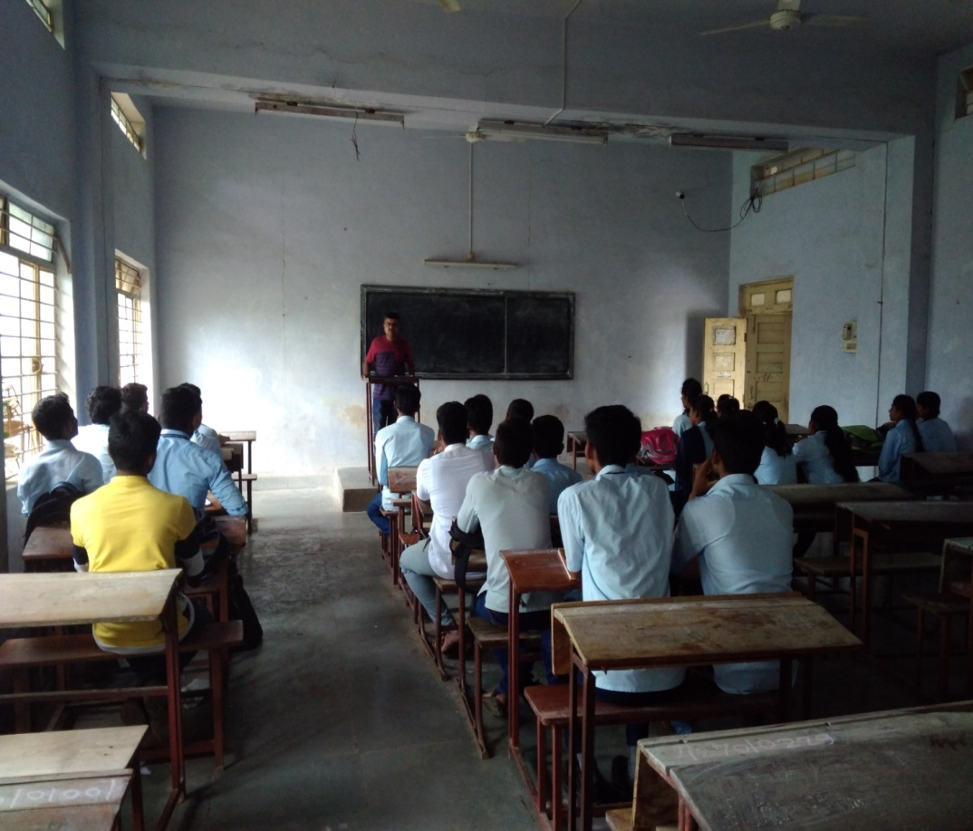

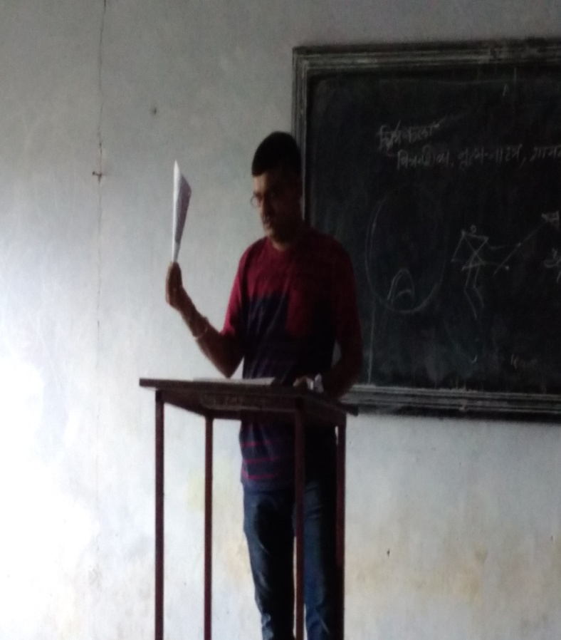

By- Prof.Wagh Sheshenath,Osmanabad Date- 18/08/2018

Sport’s Activity (Daily Activity)

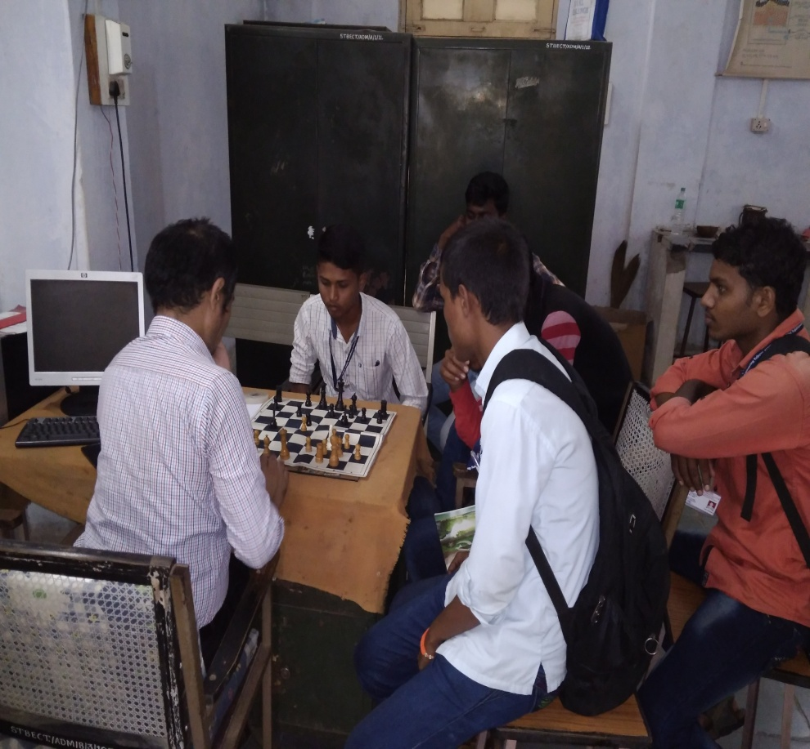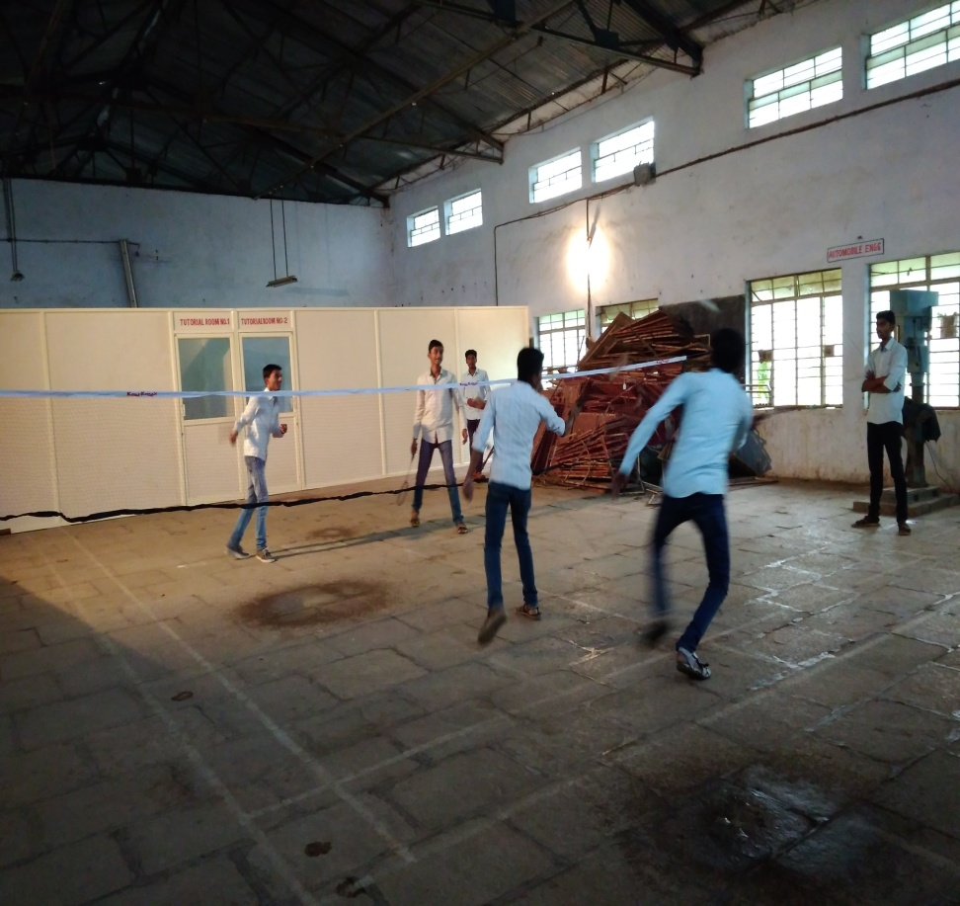

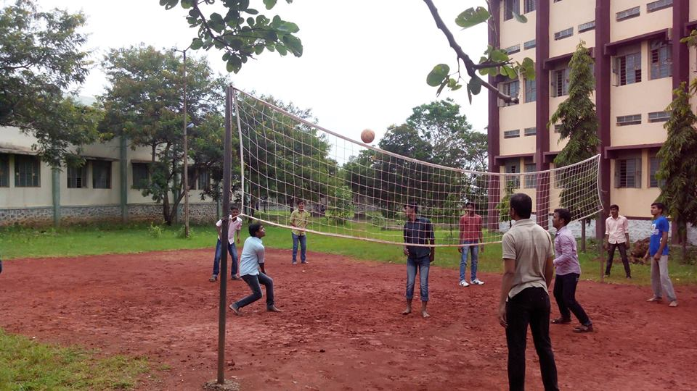
Conducted by- Gymkhana Committee Time- 4.15-5.30pm

Yoga at Hostel (Daily Activity)
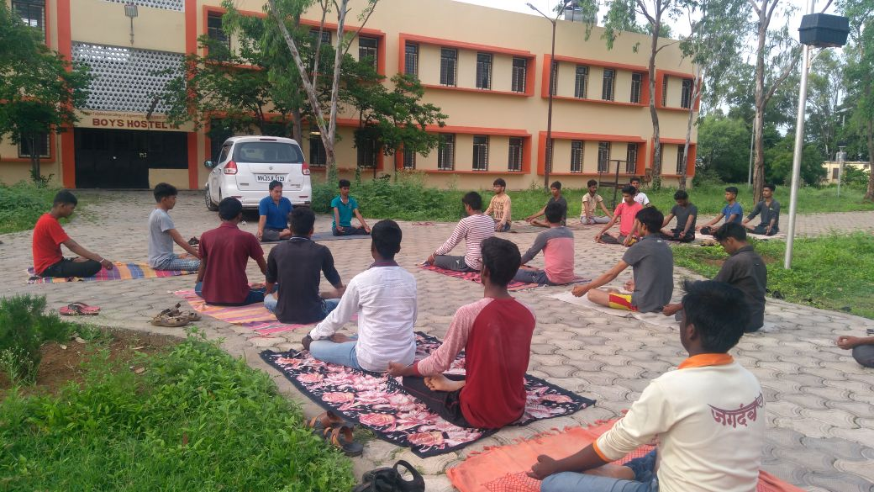

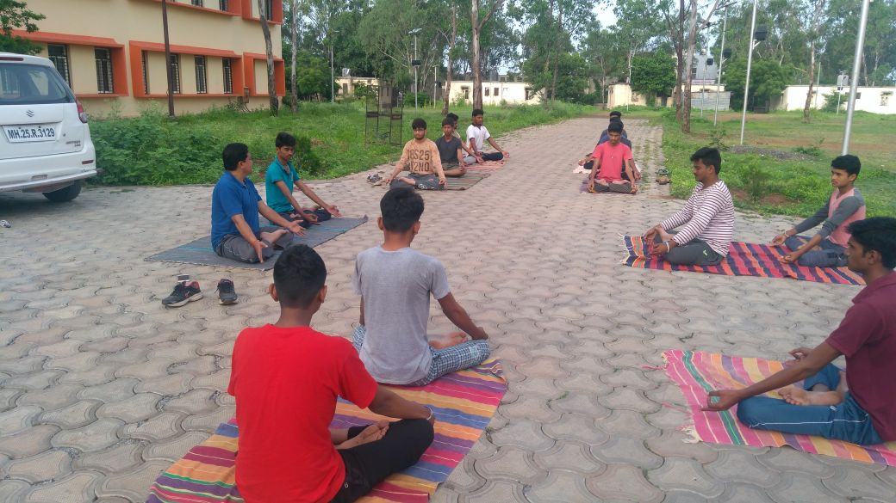

Conducted by - Prof.P.A.Hangergekar

Industrial Visit- Solar Power Plant – Andur

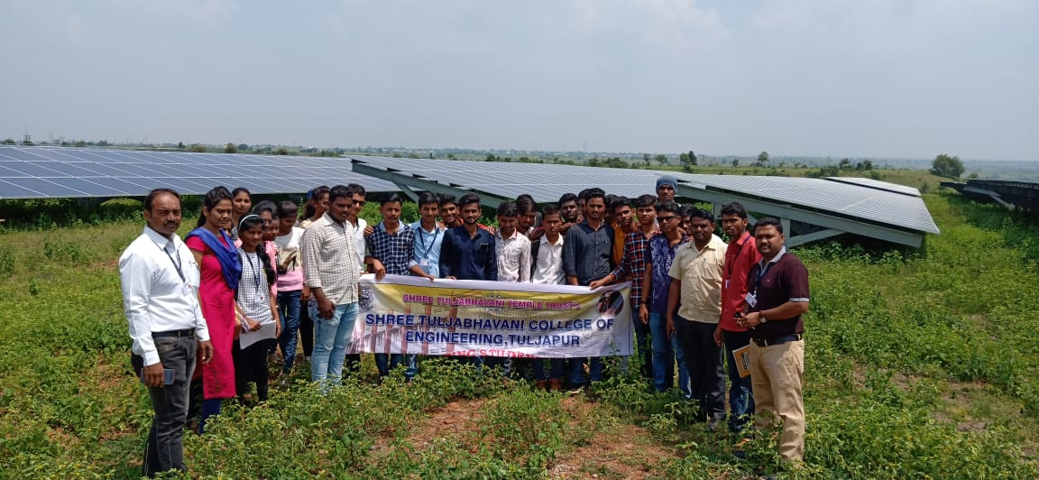

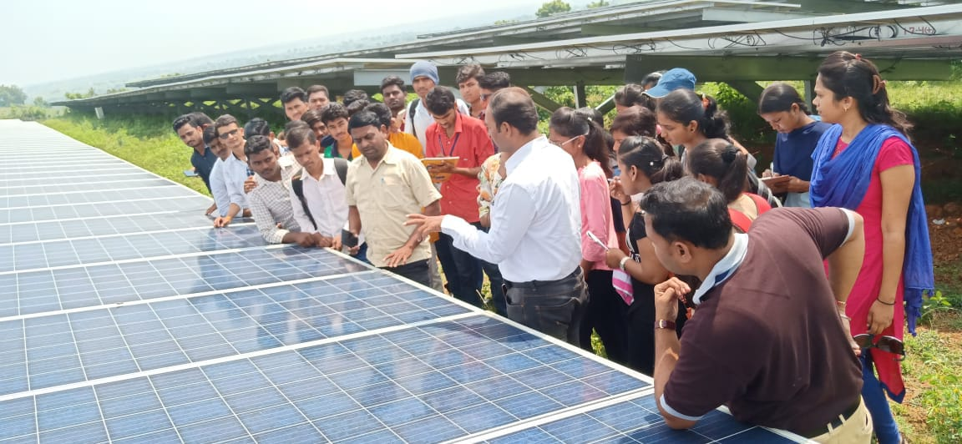

- Akashwani - Osmanabad
