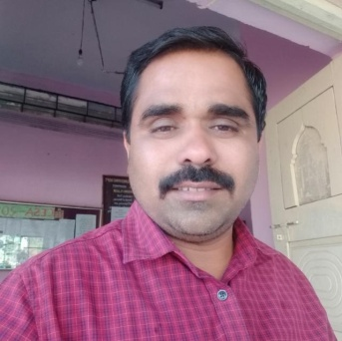

NAGNATH BIBHISHAN RAUT Railway station road, Laxmi Nagar Osmanabd Dist.: Osmanabad
State : Maharashtra.
Email : nagnath.rautl@rediffmail.com
Contact No. : +91-9422112233

CARRIER OBJECTIVE:
Apply an outstanding efforts with devotion to achieve hundred percent satisfaction to ourselves & organization, you will automatically get which you desire.

PERSONAL PROFILE:

- Date of Birth : 18th Feb 1987
- Father’s Name : Bibhishan Namdeo Raut
- Language : Marathi, Hindi & English
- Gender : Male
- Marital Status : married
- Nationality : Indian
- State : Maharashtra
- Religion : Hindu
- Hobby : Playing Cricket, Reading News paper.

PROFESSIONAL & EDUCATIONAL QUALIFICATIONS:

QUALIFICATION | UNIVERSITY/INSTITUTION | PERCENTAGE | YEAR
M.E(Structural Engineering) | Dr. BAMU Aurangabad  MGM’S JNEC Aurangabad | 61.68 %  First class | 2017
B.E (Civil) | Dr. B. A. M .U, Aurangabad.  S.T.B.C.E TULJAPUR | 71.43 %  Ist Class with Distinction | 2009

TEACHING EXPERIENCE-

Name of Institute | FROM | TO | TOTAL EXPERIANCE
B G SHIRKE CONSTRUCTION TECHNOLOGY PVT. LTD | 16/09/2009 | 30 Jan 2010 | 4.5 Month
S.S.S.P.M BARSHI | 01/02/2010 | 30/05/2010 | 4 Month
Shri Tuljabhavani college of  Engineering , Tuljapur | 04/06/2010 | Till Today | 9 year

SUBJECT TAUGHT
1) Engineering mechanics 2)Foundation Engg. 3) Basic Civil Engineering
4) Advanced Structure 5) TOS-II 6) Concrete Technology

SEMINAR AND WORKSHOP
1) Two week AICTE Sponsored faculty development programme on basis of
structural dynamics and seismic design @ Annasaheb Dange college of
Engineering & Technology Ashta, Sangali
2) A Workshop on Limit State Design of steel structures @ MIT Aurangabad.

PAPER PRESENTED
- Presentation of paper on ‘Effect of change in thicknesses and heights in shear wall on deflection, story drift and stiffness of multistoried buildings” in 9 th INTERNATIONAL CONFERENCE ON RECENT INNOVATIONS IN SCIENCE, ENGINEERING AND MANAGEMENT ISBN:-978-93-86171-22-1 organized by Dhruva institute of Engineering and Technology Toopranpet(V)Choutuppal(M) Nalgonda(Dt)
- Presented a paper on “Effect of change in thicknesses and height in shear wall on deflection of multistoried buildings” in INTERNATIONAL JOURNAL OF CIVIL ENGINEERING & TECHNOLOGY
- Presented a paper on “Effect of change in thicknesses and heights in shear wall on deflection, story drift and stiffness of multistoried buildings” in INTERNATIONAL JOURNAL OF ADVANCE RESEARCH IN SCIENCE & ENGINEERING ISSN(O):2319-8354, ISSN(P)2319-8346

EXPERIENCE OTHER THAN TEACHING-
1) Worked as Class coordinator, Test coordinator in college.
2) As a Understudy in University Examination.
3) Worked as a member of ii) A.I.C.T.E college committee.
iii) Admission committee.

DECLARATION:

I hereby declare that the above information provided by me is true to the best of my knowledge and beliefs.

DATE:
PLACE: Tuljapur
( RAUT NAGNATH BIBHISHAN)

