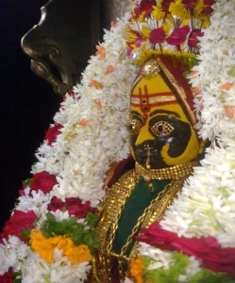
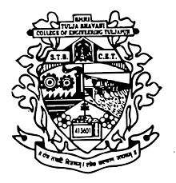
Shree Tulja Bhavani Temple Trust’s
Shri Tulja Bhavani College of Engineering, Tuljapur
Department of Mechanical Engineering
Faculty Profile
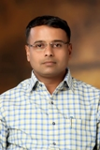
Name :Surwase Sanjay S
Designation :Assistant Professor
E-mail Id : surwasess@rediffmail.com
Contact No. : 94224656777
Educational Qualification 1. Ph.D. (Pursuing )
2. M.E (Production)
3.B.E. (Mechanical)
Professional Experience INDUSTRIAL – 02
TEACHING -- 25
Total Experience : 27
Responsibility Handled: 1. Academic Coordinator
2. Additional Charge of Workshop Superintendent
Course/ Seminar/Workshop/FDP Attended:
2016 – ISTE approved one week Short Term Training Programme on “Optimization Techniques In mechanical Engineering” organized by Department of Mechanical Engineering, N B Navale Sinhgad College of Enginerring,Solapur during 26th- 30th December,2016.

2016 – ISTE approved one week National level Short Term Training Programme on “Modelling & Simulation” organized by Department of Mechanical Engineering,Maharashtra Institute of Technology,Aurangabad during 27th June to 02nd July,2016.

2016 - One Week workshop on “Developments in Welding Technology” March 8-12,2016 under TEQIP organized by Department of Mechanical Engineering, Dr.Babasaheb Ambedkar Technological University, Lonere, Dist Raigad.

2013 – One week TEQIP-Short Term Training Programme on “Soft computing Tools and its Applications in Engineering (SOCTAPE-2013)”during3-7,June-2013 sponsored by TEQIP Phase-II under CEP at Government College of Engineering, Aurangabad.

2012 – Two-week ISTE workshop on “Introduction to Research Methodologies” conducted by Indian Institute of Technology Bombay from 25th June to 4th July,2012 under the National Mission on Education through ICT(MHRD)

2009 – One Week training program on” Finite Element Analysis (FEA).Sponsored by TEQIP, organized by Department of Automobile Engineering, RIT rajaramnagar, during10th-14th February, 2009.

2008 – Two days workshop on “Research Methodologies”Organized by the Department of Mechanical Engineering ,Maharashtra Academy of Engineering Alandi,Pune,During 28th & 29th February 2008.

2006 – One Week Short Term Course on “Smart Actuators” during March 27-31, 2006, sponsored by ISTE and organized by Department of Mechanical Engineering,B.L.D.E.A’s Vachana Pitamaha Dr.P.G.halakatti college of engineering & Technology,Bijapur.

2004 – National conference on Machine Design held on 27th & 28th Feb,2004, organized by Department of Mechanical Engineering of Amrutvahini College of Engineering,Sangamner.

2003 – Two Weeks AICTE-sponsored Staff development programme on “Recent Developments In Manufacturing Technology”from 15th to 27th December 2003,conducted by the Department of Mechanical Engineering, M V S R Engineering College Hyderabad.

2002 - Two weeks ISTE-AICTE sponsored Short Term Training Programme on “Opportunities and Challenges in High Precision Manufacturing: Vision 2020” organized by Department of Mechanical Engineering of Dr.Babasaheb Ambedkar Technological University, Lonere during November 18-30.2002

2000 - Two Weeks Faculty Development Programme conducted by MITCON in association with STBECT sponsored bythe Department of Science & Technology,New Delhi.during August 16-29,2000.

Guest Lecture / Workshop / Seminar Delivered/Conducted:
-
Publication Details (Journal/Conference)
- R.H. Aadekar, V.B. Pansare, S.S. Surwase “Evaluation of productivity & Tool life serration Operation” ISSN 2277-2685 IJESR/June 2016/ Vol-6/Issue-6/136-142.

- R.H. Aadekar, V.B. Pansare, S.S. Surwase “Evaluation of Tool life in face serration Operation” ISSN: 2394-3696 IJIERT VOLUME 3, ISSUE5, MAY-2016.

- A.S.Adkine,G.P.Overikar,S.S.Surwase”Modal Analysis of Engine Supporting Bracket using Finite Element Analysis” ISSN: 2349-6495(P) IJAERS Vol-4, Issue-3, Mar-2017.
- A.S.Adkine,G.P.Overikar,S.S.Surwase”Static & Modal Analysis of Engine Supporting Bracket”IJMTER Vol-3, Issue-11, Nov-2016.

No of Projects Supervised:
PG – 03
UG – 15
Association with Professional Bodies :Life member of Indian Society for Technical Education (ISTE), New Delhi.

S S SURWASE
Assistant Professor(Mechanical)

